|  |
| --- |
|  |
| File Management System for Windows 8 Phone |
| Synopsis |
|  |
| **Susmita Podder( 105140695 )** |
|  |

|  |
| --- |
|  |

Table of Contents

Introduction & OBJECTIve 3

INTRODUCTION 3

Objective 3

PROJECT CATEGORY 3

Hardware and Software Specification 3

Hardware Requirement 4

Software Requirement 4

REQUIREMENTS AND ANALYSIS 4

Problem Definition 4

Existing System 4

Documents maintained 6

Work To Be Done 7

Requirements Specification 7

Functional Requirements 7

technical specification 10

Planning and Scheduling 10

Gantt chart 10

Tracking Gantt 11

Pert chart (Network Diagram) 12

Scope of the Solution 12

Analysis 13

Context Diagram 13

Data Flow Diagram 13

Level 0 DFD 13

Level 1 DFD 14

Level 2 DFD 16

E-R Diagram 16

Class Diagram 20

Database & Table Details 20

COMPLETE DATA STRUCTURE 22

Module Description 22

School Management Server 22

School Management Client 23

School Management Database 23

estimation 23

Data Structure 24

Implementation Methodology 27

List of Reports 27

sECURITY MECHANISM 27

FUTURE SCOPE AND FURTHER REQUIREMENTS 28

bIBLIOGRAPHY 28

# Introduction& OBJECTIVE

## Introduction

We all know that Windows Phone 8 is one of the most popular smart phones Operating System in the world. When I started using a Windows Phone I was amazed to see its usability, features and looks & feels. Still, nothing is perfect in this world. After switching from Symbian to Windows, I felt faced problems on some basic features; one of them is a File Manager.

It was really easy to access phone memory and Memory card (micro SD) memory in Symbian but windows Phone does not provide such feature. I spoke to other windows phone users on social networking sites and understood that they are facing same problem as well.

So, it was not hard for me to decide my project topic, I chose to develop an application which would let a user access phone memory and SD card memory. It obviously is going to be a very useful app for all the Windows Phone users in the world.

## Objective

Windows Phone File Manager is a mobile application that allows a windows phone user to do following things:

1. Browse SD card.
2. Browse phone memory.
3. Browse files by category, like .txt files, .mp3 files etc.
4. Archived file reader and extractor.
5. Upload data to cloud storage (skydrive).
6. Synchronization with cloud storage.
7. Password protection of selected files and the entire app.
8. PDF Reader.
9. Sorting/Searhing based on file format.
10. Files sharing through Bluetooth/ wifi/ data cable.

The file manager comes with a desktop application as well, that allows user to,

1. Synchronization between phone memory/ SD card memory and the computer.
2. Browse phone memory files and memory card files from the computer.
3. Synchronization between cloud storage (Skydrive, Google drive, dropbox) and back up of SD card/ phone memory files.

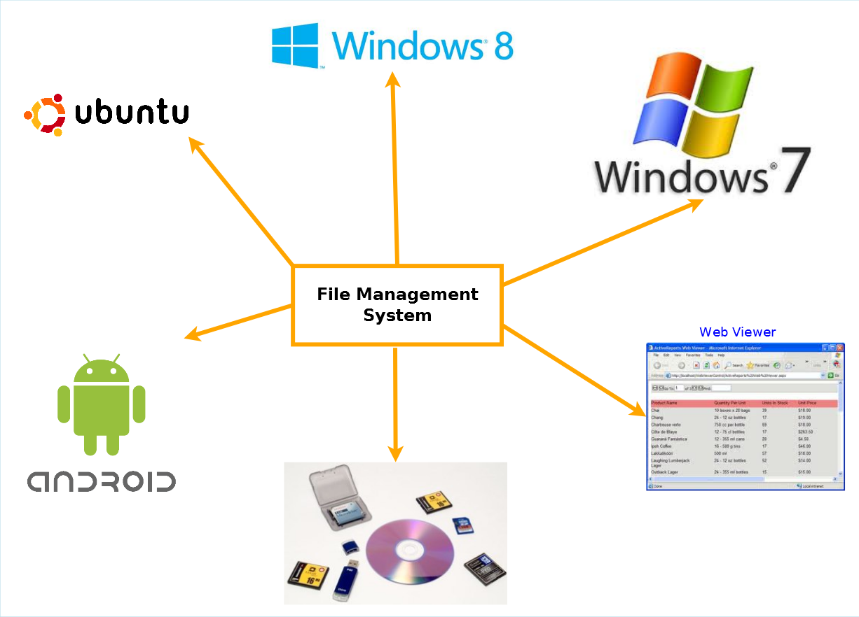

File Management System is divided in to following modules:

|  |
| --- |
| File Management System Web Controller |
| Android Client |
| Windows 8 Client |
| Windows 7 Client |
| Ubuntu (Linux) Client |
| Storage Device Controller |
| Server REST API |
| FMS Search Engine |
| Web Sync Handler |
| Web Viewer Client |

# PROJECT CATEGORY

This software will follow Object Oriented Programming Paradigm and use below mentioned areas:

OOP Language: C#

RDBMS: SQLite.

Networking:

Applications: Mobile Systems

# Hardware and Software Specification

## For Mobile:

### Hardware Requirement

* **Phone Memory/SD Card Memory :** 300 MB of available hard disk space
* **RAM :** 128 MB or higher
* **Processor :** 484 MHz or faster

### Software Requirement

* Windows 08

## For Desktop

### Hardware Requirement

* Disk Space: 50 Mb of available disk space.
* RAM: 256 MB
* Processor: 1 GHz dual core

### Software Requirement

* Windows XP, Windows 07 Operating System.
* Microsoft .NET framework 3.5.

# REQUIREMENTS AND ANALYSIS

## Problem Definition

### Existing System

The existing system allows a Windows Phone user use their SD card and phone memory data in a very confusing way. For example, it sends all the windows phone application files (.xap files) in a folder called SD card. But, after copying the files to the SD card, it does not show the files instantly. Also, it needs a reboot to make the apps visible on that place and sometimes they do not appear there even after rebooting the device.

The .mp3 files, which are supposed to be appeared inside the music player, are hard to find among hundreds of songs.

The synchronization between mobile and computer is very confusing as well.

### our target

Using our application, the users can browse the SD card and phone memory directly and they can just browse the location folder where they kept the file from computer. So there is no waiting and no confusion while installing a game or playing a video.

### Work To Be Done

We will incorporate the above mentioned workflow of Windows Phone File Management System in a automatic computerized way.

## Requirements Specification

### Functional Requirements

#### bROWSE sd CARD FILES

**Introduction**

The user can browse their documents kept in the SD card using the application.

**Input**

Open the application and click on browse SD card files.

**Processing**

The app will search for the SD card attached in the phone and show them to the user just like a computer.

**Output**

The user can browse all the files and folders of the SD card.

#### Browse Phone memory

**Introduction**

Users can browse their phone memory from the application.

**Input**

Users open the application and click on browse phone memory.

**Processing**

The application searches for the phone memory structure and asks for permission from the phone to share the information to the user.

**Output**

Users can see all the files, folders of the SD card.

#### Security

**Introduction**

The application will be password protected.

**Input**

Users click on the application and provides predefined password to use the application.

**Processing**

The application takes the password input and compares it with the predefined password stored in SQLite database.

**Output**

Only after providing a valid password, the user gets access to the application.

#### read pdf files

**Introduction**

The application should be able to read PDF files from the Windows phone.

**Input**

The user browses and opens a PDF file stored in phone memory or SD card.

**Processing**

The application asks for permission from the mobile OS to use their PDF reading utility.

**Output**

The PDF gets opened and the user can read it.

#### Archived file reader

**Introduction**

The application can read and extract an archived file from inside the mobile.

**Input**

The user will browse and select an archived file to be extracted somewhere inside the SD card or phone memory.

**Processing**

The application extracts the archived file at the predefined location.

**Output**

The user gets the files extracted from archived format to a normal file.

#### Store data to cloud

**Introduction**

The user will be able to store the selected data to the skydrive account.

**Input**

The user clicks on store to cloud option and chooses a file to be kept at the cloud.

**Processing**

The application uses the mobile’s online backup utility to store the data to cloud.

**Output**

The data gets stored to the cloud so the user is able to use them from anywhere, a desktop or a laptop or from other mobile phone using an internet connection.

#### lock individual files

**Introduction**

The application should be able to lock individual files as per users’ instruction.

**Input**

The user taps on a file and chooses lock the file.

**Processing**

The application makes the file locked and asks for a predefined password if someone attempts to open that particular file.

**Output**

Only with a valid password, a user can open the file.

#### sorting of files

**Introduction**

The application should be able to sort files inside a folder.

**Input**

The user browses inside a folder and chooses to sort all files inside it.

**Processing**

The application recognizes the formats of the files and sorts them alphabetically.

**Output**

The user gets all files sorted by file types.

#### seareching of files

**Introduction**

The application should be able to search a file by its name from the phone memory and the SD card.

**Input**

The user writes name of a file inside the search text field and clicks on search.

**Processing**

The application looks for all the related data similar to the file name inside the phone and SD card memory.

**Output**

The user gets all the files similar to the name he provided inside the text field.

#### data sharing

**Introduction**

The application should be able share data through usb cable, Bluetooth or wifi.

**Input**

The user taps on a file and chooses share (using Bluetooth/wifi/usb cable)

**Processing**

The application instantly searches for availability of the device with which the file is to be shared and attempts to send the data to the device.

**Output**

The data gets shared as per users’ requirement.

### non Functional Requirements

* **Efficiency**:

It will be efficient as it reduces manual labor and searching.

* **Backup**:

Data could be stored to online storage.

* **Documentation**:

The application will have users’ manual pdf inside the help section.

* **Maintainability**:

It is designed such a way that it can be maintained with minimal effort.

* **Performance**:

The response time of file manager will be very fast. So it will be efficient enough to cater the user.

* **Privacy**:

The data will be encrypted and the user data will not be shared with third party without proper authentication.

* **Looks & Feels**: Should have very attractive looks and feels to make the user happy even by opening it.

ESCMS will use secure connection and enhanced security measures to protect data.

* **Usability**:

It will be very user friendly and usable by any person with minimal computer knowledge.

### Technical specification

#### For mobile app

* **Front End/ GUI Tools:** XAML (Extensible Application Markup Language)
* **IDE:** Visual Studio Express 2012 for Windows Phone
* **Framework:** Microsoft .NET 4.0
* **Database:** Sqlite.
* **SDK:** Windows Phone SDK 8.0.
* **Cloud Technology:** SkyDrive

#### For desktop app

* **Front End/ GUI Tools:** Windows Presentation Framework (WPF)
* **IDE:** Visual Studio 2010
* **Framework:** Microsoft .NET 4.0
* **Database:** MySQL
* **Database Tool:** MySQL workbench CE
* **Operating Systems**: Windows XP, Windows 7
* **Cloud Technology**: Google Drive, Dropbox, SkyDrive

## Planning and Scheduling

### Gantt chart

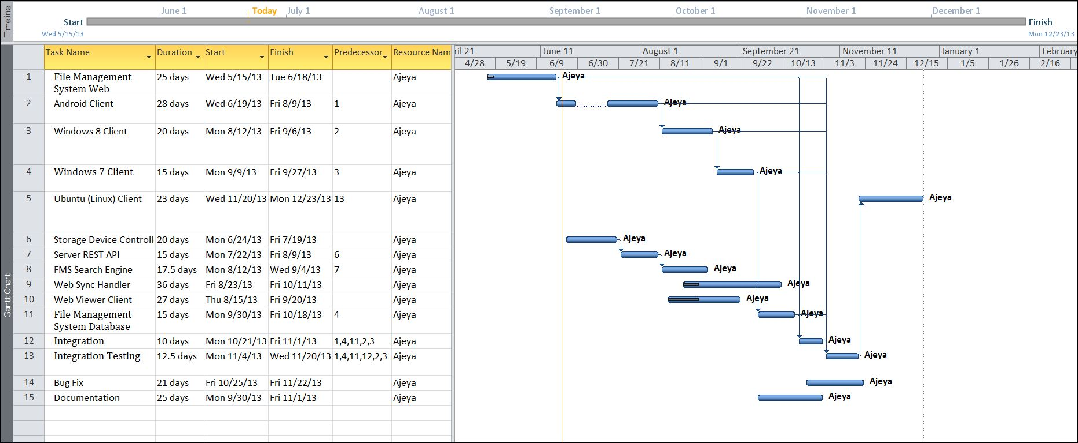

### Tracking Gantt

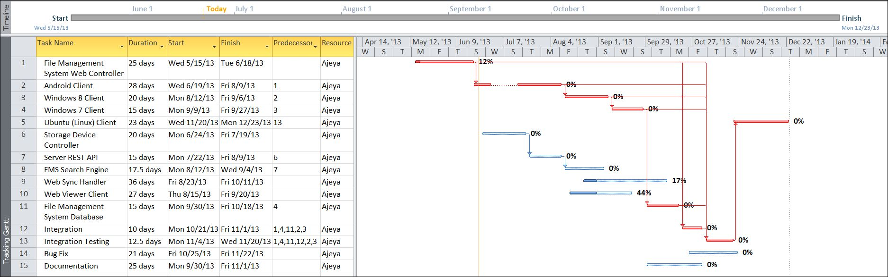

### Pert chart (Network Diagram)

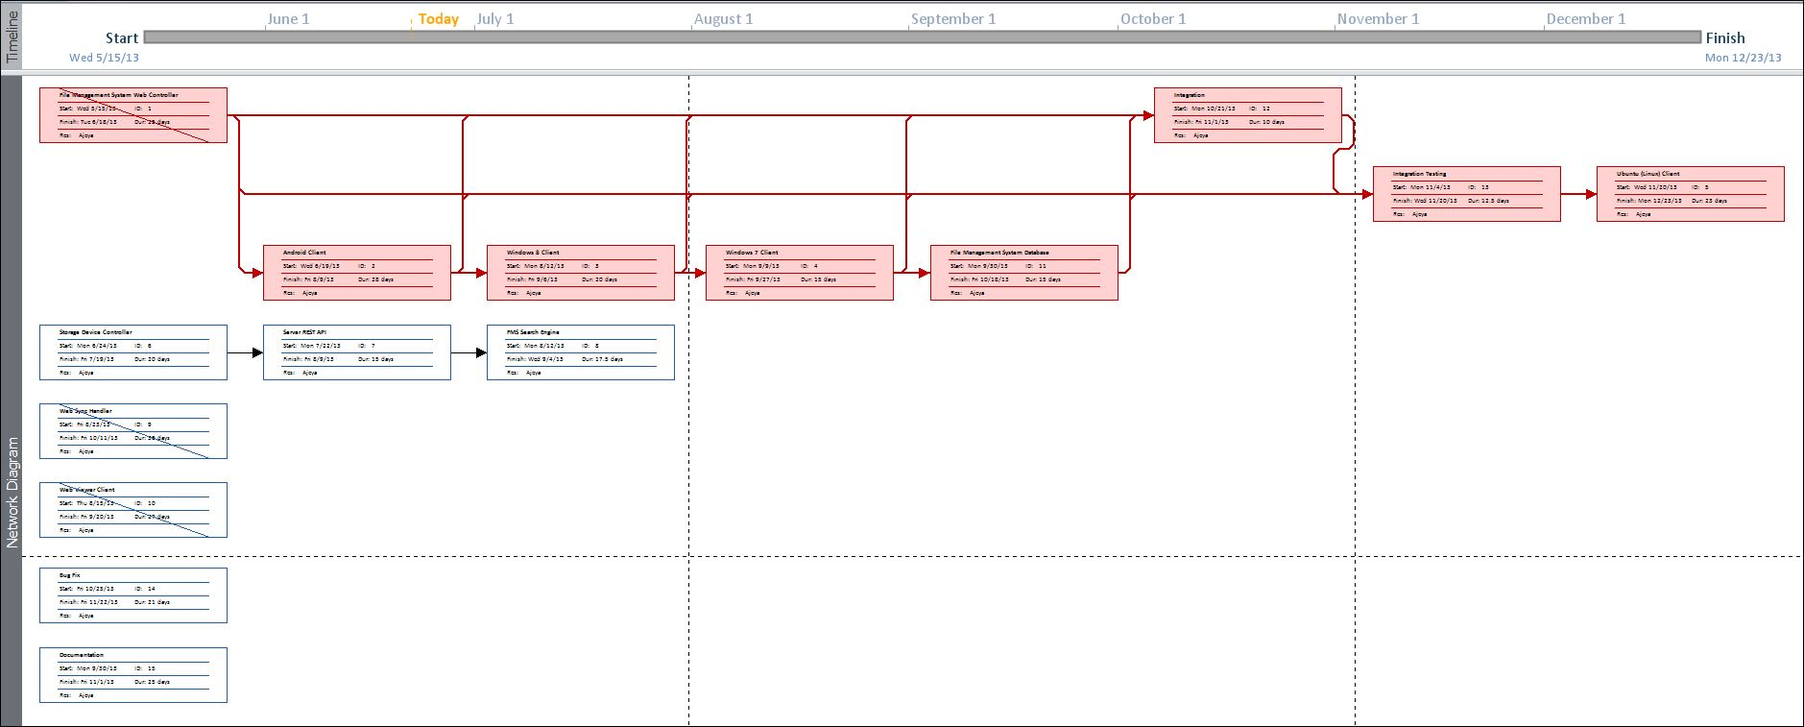

# Scope of the Solution

## for Mobile App

Following features could be attached to the app in future to make it even more useful and a complete system manager:

1. It could be made as a system hardware tracker that shows processor/RAM status (used and free).
2. Battery remaining and temperature.
3. Synchronization with Google Drive.
4. Synchronization with Drop Box.

## for Desktop App

1. Using phone data for the computer through a USB cable.
2. Mobile OS updating and reinstallation of application/OS.
3. Installation of various apps in mobile from the desktop app through usb cable.

# Analysis

## Context Diagram

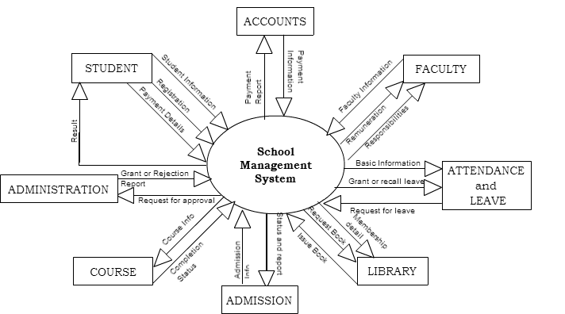

## Data Flow Diagram

### Level 0 DFD

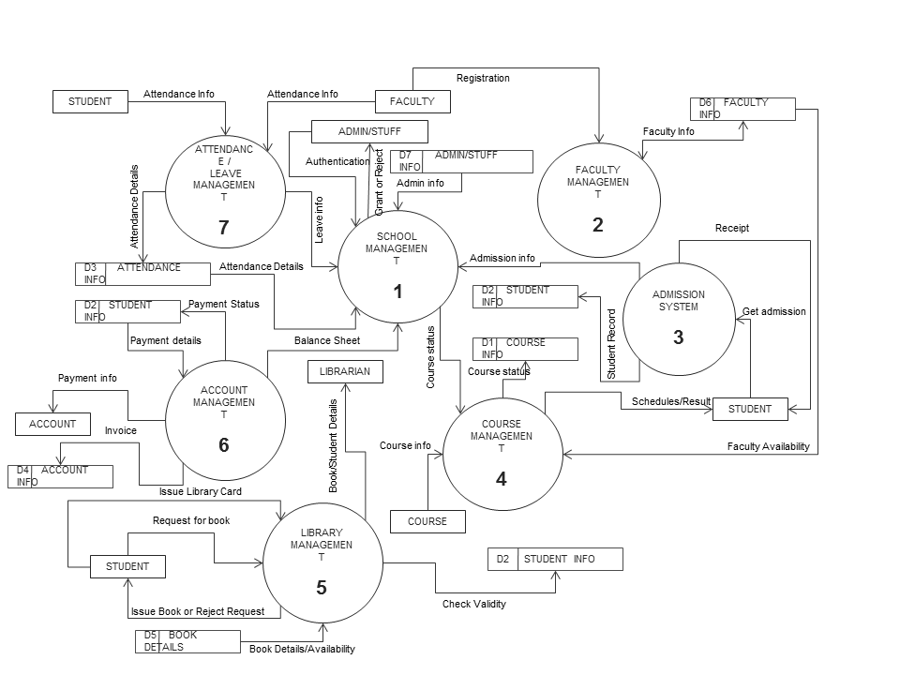

### Level 1 DFD

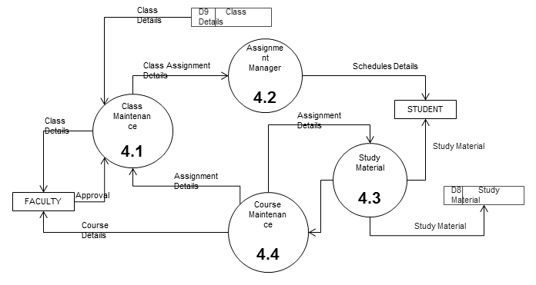

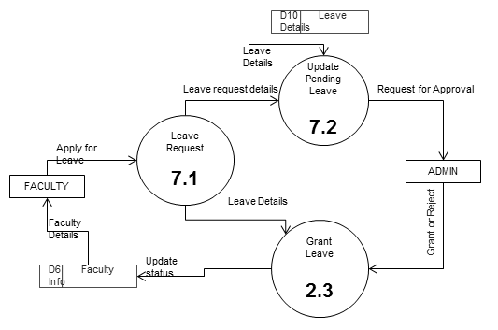

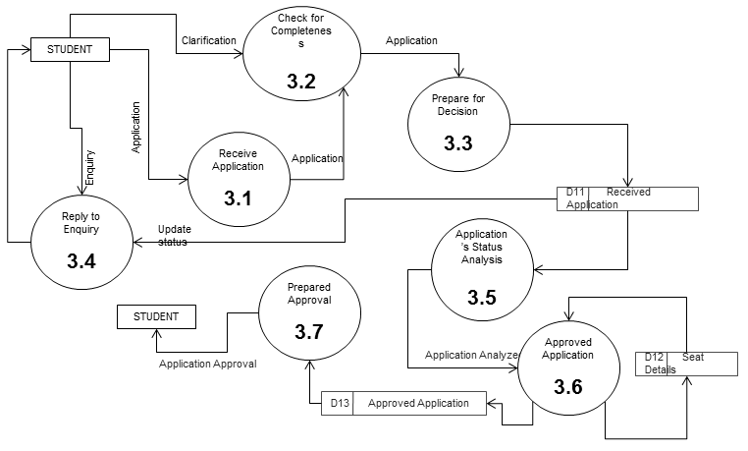

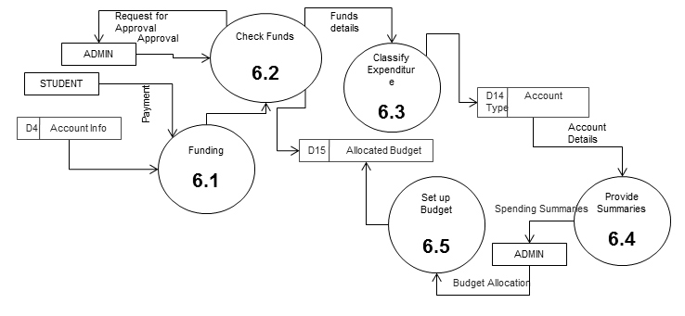

### Level 2 DFD

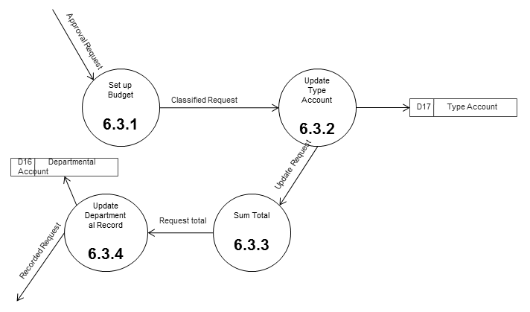

## E-R Diagram

We will design a RDBMS for School Management System. The entities and their attributes are listed below. Attributes in Bold letter is the unique key.

|  |  |
| --- | --- |
| **Entities** | **Attributes** |
| Student | **Student_ID**, Student_DOB, Student_Name, Student_Parent_Name, Student_Address, Student_Admission_Date, Student_Course_Name, Student_Contact |
| Account | **Transaction_ID**, Transaction_Amount, Transaction_Type, Transaction_Reason,Account_Balance |
| Admin | **Staff_ID**, Staff_Name, Staff_Permission_Level, Staff_Address, Staff_Admission_Date, Staff_Course_Name, Staff_Contract_details, Staff_Join_Date, Staff_Email, Staff_Role |
| Books | **Book_ID**, Book_Name, Book_Author, Purchase_Date, Book_Status, Book_Description,Purchase_Amount |
| Faculty | **Faculty_ID**, Faculty_Name, Faculty_Address, Faculty_Join_Date, Faculty_Course_Under, Faculty_Contact_Details, Faculty_Salary_Details |
| Course | **Course_ID**, Course_Faculty, Course_Name, Required_Qualification, Course_Fees, Course_Admission_Date, Students_Under, Course_Description |

**Relationship between Entities:**

School Management System has Courses 1 : N

School Management Systemhas Students 1 : N

School Management System has Faculties1 : N

School Management System has Admin 1 : 1

Studenthas Attendance 1 : 1

AdminChecksAttendance 1 : 1

StudentsreadsBooks M : N

StudentspaysAccount 1 : 1

AdminControlsAccount 1 : 1

Students Studies in Course N:1

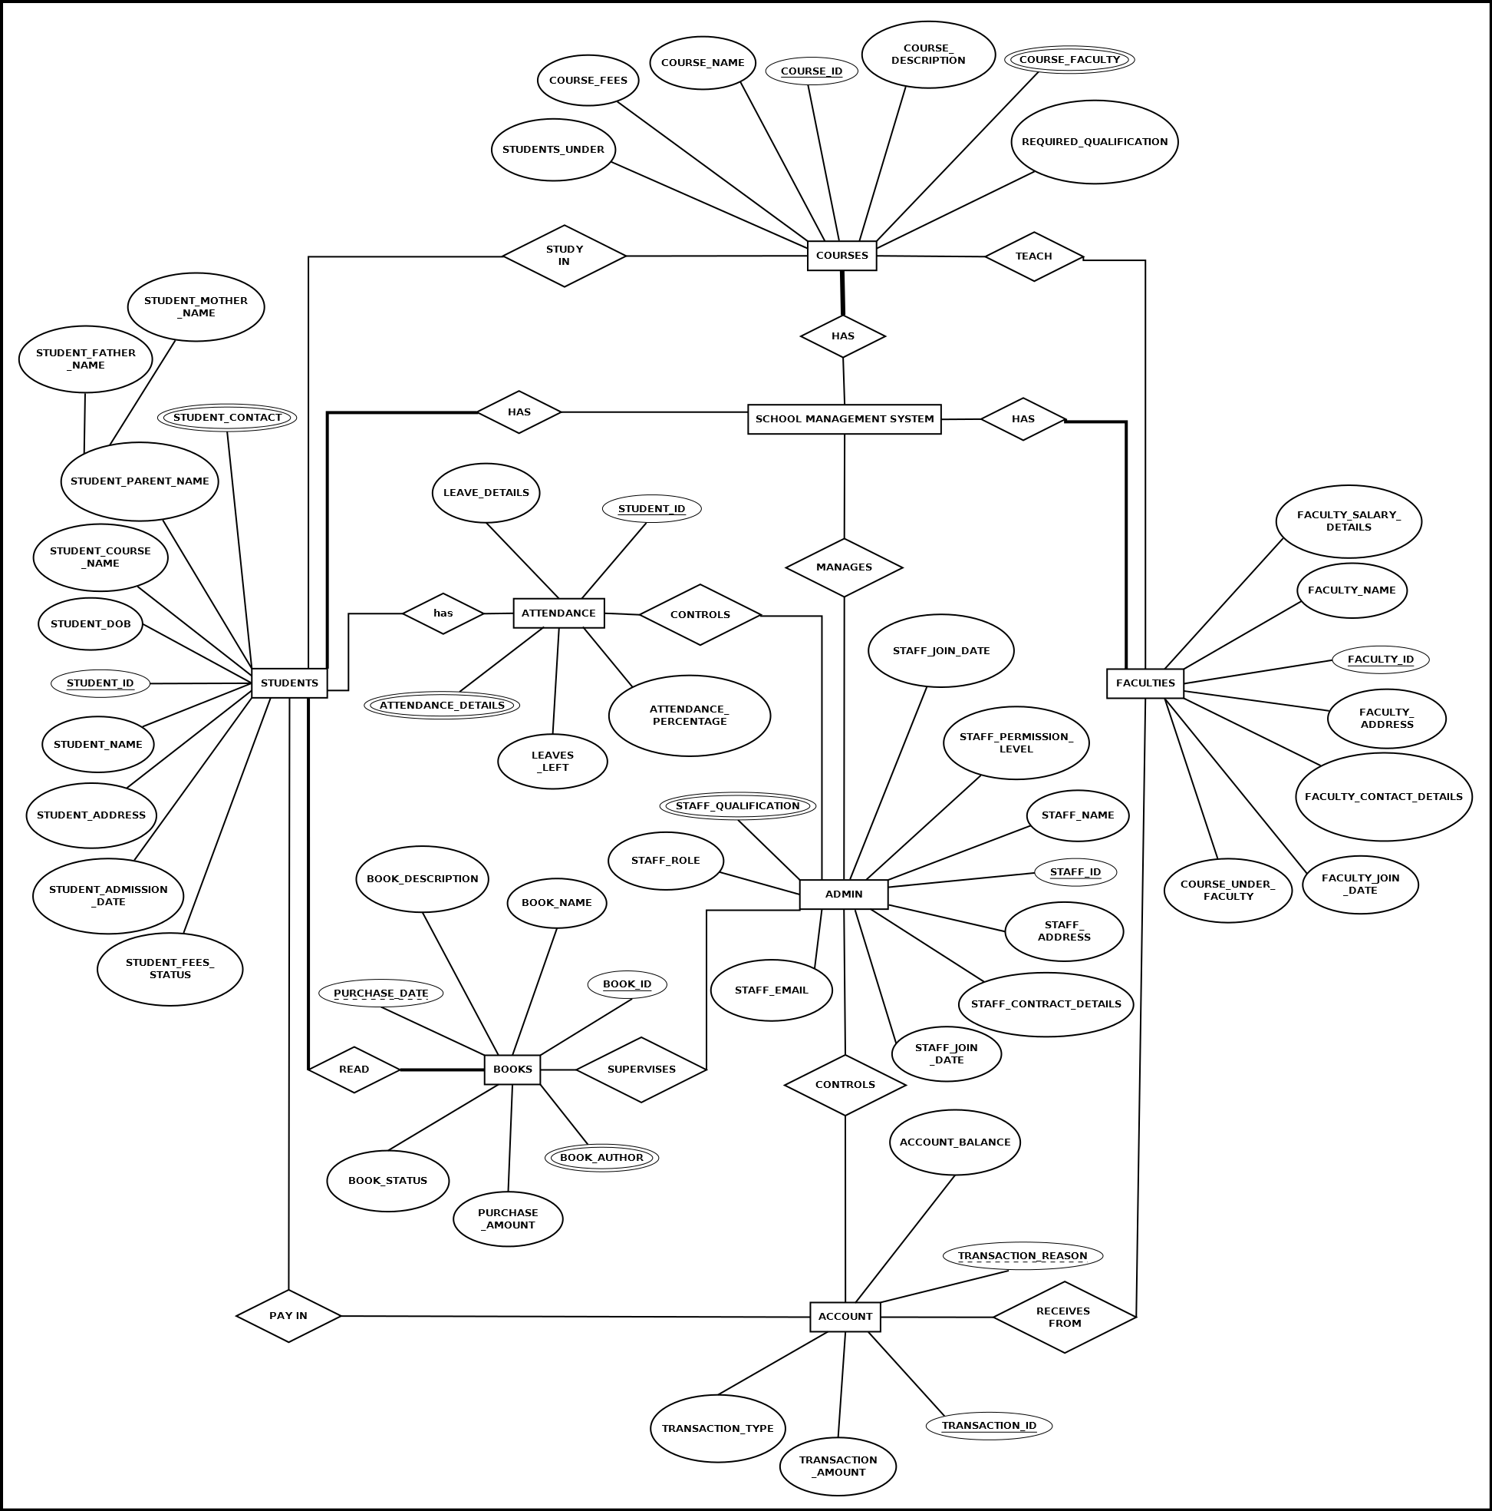

## Class Diagram

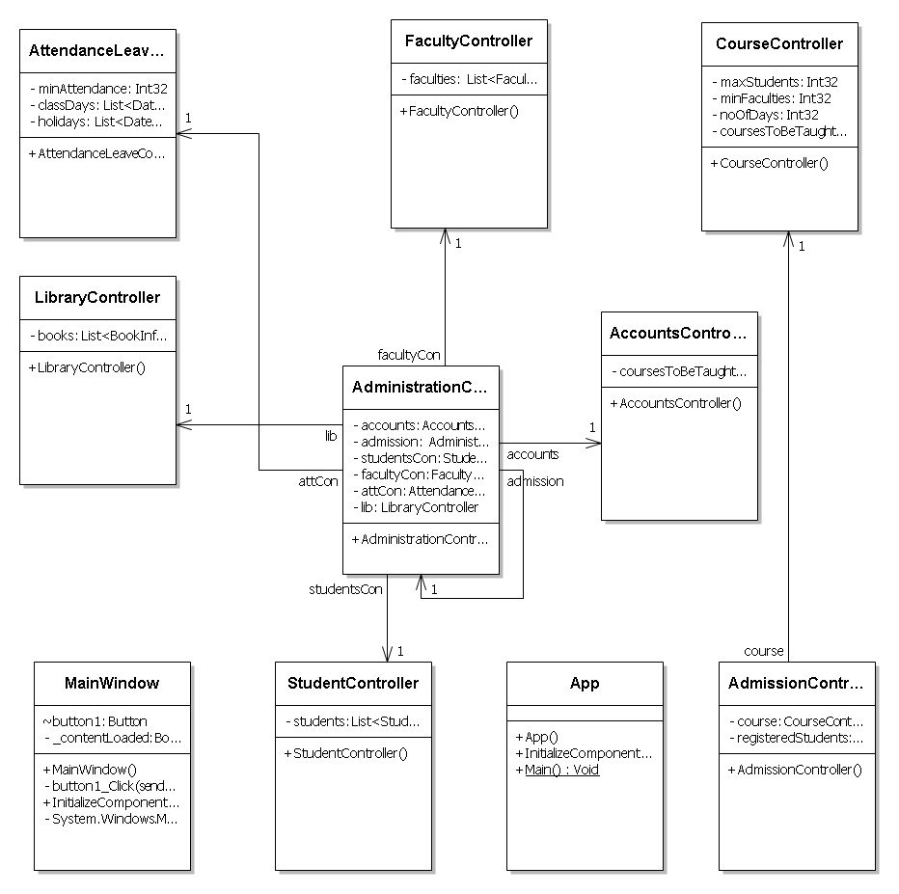

# Database & Table Details

The database used for this software is called **smsdb**. A screenshot from the MySQl workbench is given below. It shows the tables and its columns. The first row is the primary key.

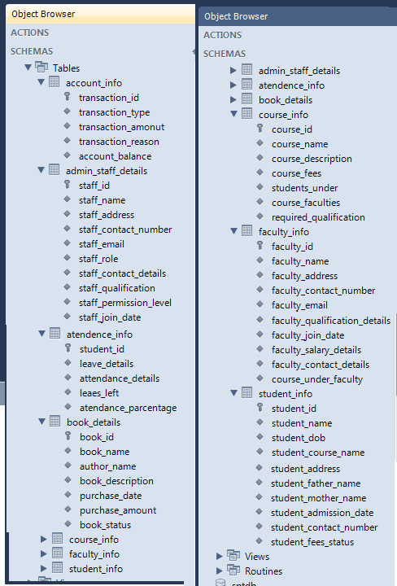

# COMPLETE DATA STRUCTURE

## Module Description

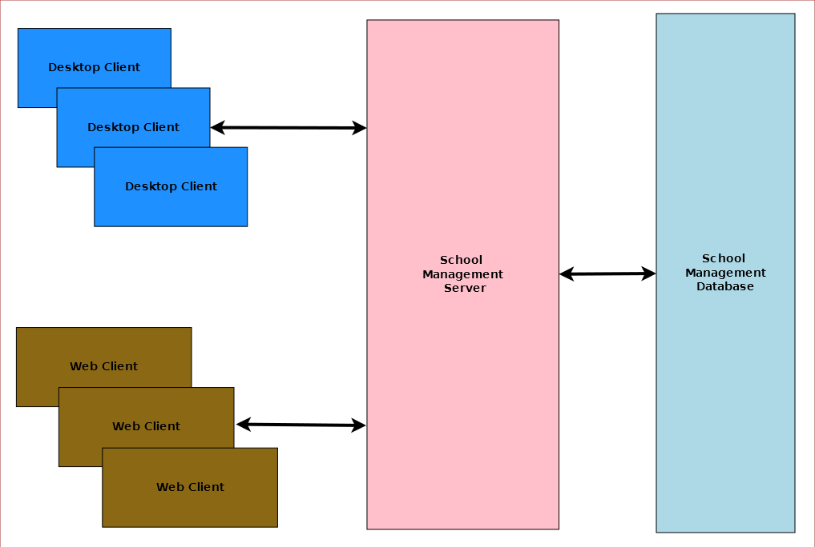

School Management System is divided three main modules such as:

1. School Management Server
2. School Management Client
3. School Management Database

### School Management Server

School Management server is a singleton server designed provide services for school management system. It controls various activities required for the school management system. To manage these activities it has several sub modules such as:

1. Admission Management
2. Student Management
3. Faculty Management
4. Course Management
5. Attendance & Leave Management
6. Library Management
7. Accounts Management
8. Administration Management

### School Management Client

School Management System will provide two different clients for the convenience of the user. Desktop client is for doing bulk activities and faster tasks. Web client will allow instant access from anywhere and anytime.

### School Management Database

School Management System will have a unified database for storing all the information. It can be a networked database or a database situated in the server machine.

## Estimation

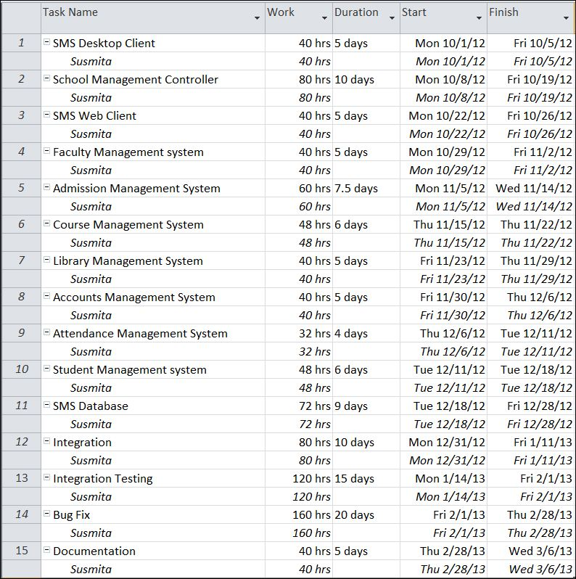

## Data Structure

|  |
| --- |
| **StudentInfo** |
| publicclassStudentInfo  {  publicstring id { get; set; }  publicstring name { get; set; }  publicstring bloodGroup { get; set; }  publicstring phone { get; set; }  publicstring address { get; set; }  publicDateTime admissionDate { get; set; }  publicDateTime dob { get; set; }  } |

|  |
| --- |
| **CourseInfo** |
| publicclassCourseInfo  {  publicstring id { get; set; }  publicstring eventTitle { get; set; }  publicDateTime eventDoe { get; set; }  publicstring eventVenue { get; set; }  publicstring eventGoal { get; set; }  } |

|  |
| --- |
| **ExpenseInfo** |
| publicclassExpenseInfo  {  publicstring id { get; set; }  publicstring purpose { get; set; }  publicDateTime doe { get; set; }  publicstring expensed_by { get; set; }  publicdouble amount { get; set; }  } |

|  |
| --- |
| **FundInfo** |
| publicclassFundInfo  {  publicstring id { get; set; }  publicstring wellwisher_name { get; set; }  publicstring contact { get; set; }  publicDateTime dod { get; set; }  publicstring received_by { get; set; }  publicdouble amount { get; set; }  } |

|  |
| --- |
| **FacultyInfo** |
| publicclassFacultyInfo  {  publicstring id { get; set; }  publicstring name { get; set; }  publicDateTime doj { get; set; }  publicstring address { get; set; }  publicstringphone { get; set; }  public List<string> qualifications { get; set; }  publicList<string> courses { get; set; }  } |

|  |
| --- |
| **AdmissionInfo** |
| publicclassAdmissionInfo  {  publicstring id { get; set; }  publicstring name { get; set; }  publicstringpurpose { get; set; }  publicint ageLimit { get; set; }  publicstringVenue { get; set; }  publicstringcoordinatorPhone { get; set; }  publicstring admittedAddress { get; set; }  publicDateTime examDate { get; set; }  publicDateTime resultDate { get; set; }  publicList<string> subjects { get; set; }  publicintnumberOfSeats { get; set; }  } |

|  |
| --- |
| **BookInfo** |
| publicclassBookInfo  {  publicstring id { get; set; }  publicDateTime issueDate { get; set; }  publicList<string> author { get; set; }  publicList<string> tag { get; set; }  } |

|  |
| --- |
| **TransactionInfo** |
| publicclassTransactionInfo  {  publicstring id { get; set; }  publicstring name { get; set; }  publicdouble amount { get; set; }  publicstring type { get; set; }  publicstring reason { get; set; }  publicstring receivedFrom { get; set; }  publicstring receivedBy { get; set; }  publicDateTime date { get; set; }  } |

## Implementation Methodology

* Object Oriented Programming methodology will be adopted and c sharp will be used as programming language.
* .NET framework will be used to develop desktop and mobile app.
* User interface development will be done using WPF (Windows Presentation Foundation).
* Relational DBMS MySQL will be used to implement & execute SQL query to database.
* Agile Software Development model will be used while developing this software.

# SECURITY MECHANISM

* For mobile app, password protection will used for the entire app.
* For mobile app, password protection will be used for single items, like a video or an image.
* For desktop pp, password protection will be incorporated so that the phone back up stays protected.

# FUTURE SCOPE AND FURTHER REQUIREMENTS

* The application provides only skydrive cloud storage back up. We could develop Google drive and dropbox cloud storage back up as well.
* It could be really useful if the app could provide a video and image file locker as well.

# bIBLIOGRAPHY

* <http://en.wikipedia.org>
* <http://msdn.microsoft.com/en-us/>
* <http://www.microsoft.com/en-us/default.aspx>
* <http://www.codeplex.com/>
* <http://stackoverflow.com/>
* <http://www.codeguru.com/>
* [http://www.w3schools.com](http://www.w3schools.com/)
* [www.mysql.org](http://www.mysql.org)
* IT Professionals and other Windows Phone users.